# Java compiler settings

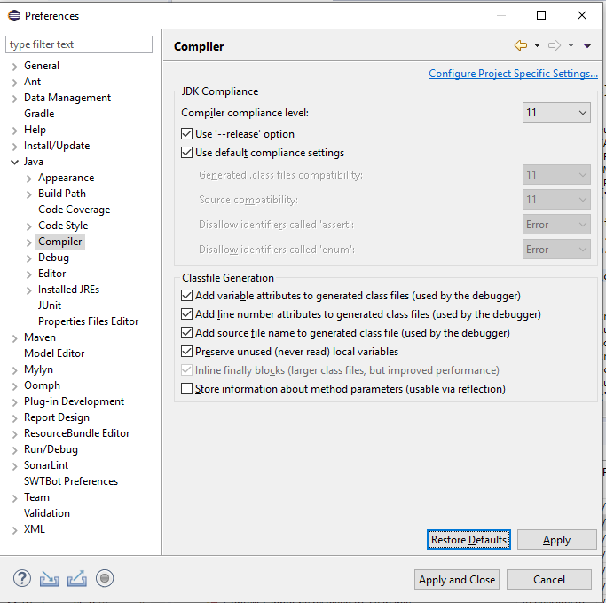

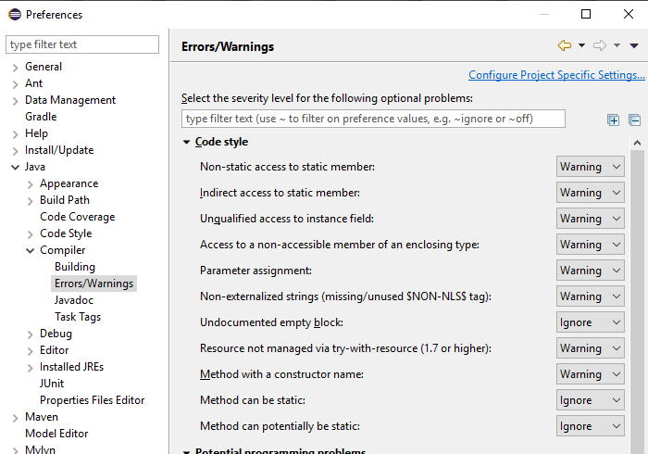

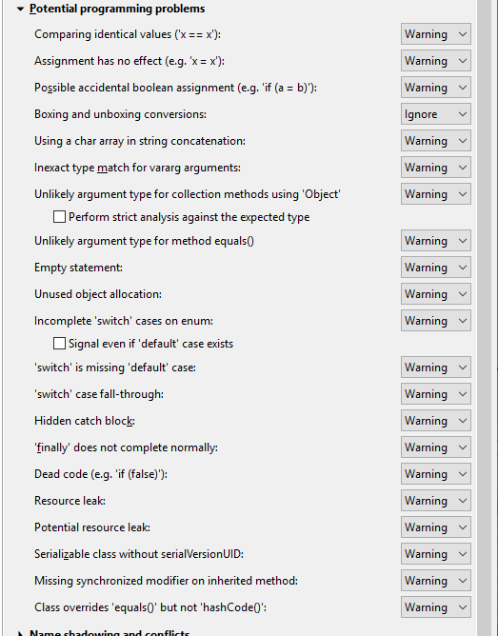

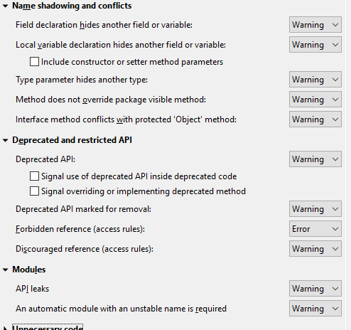

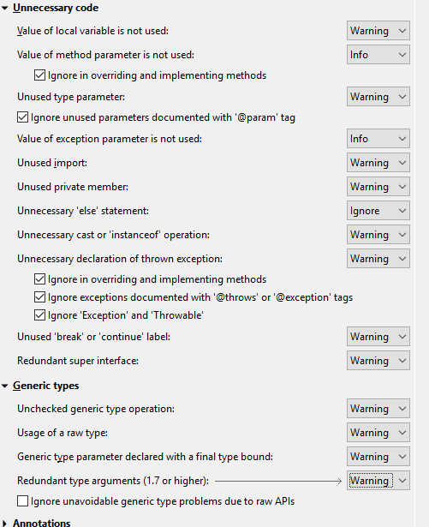

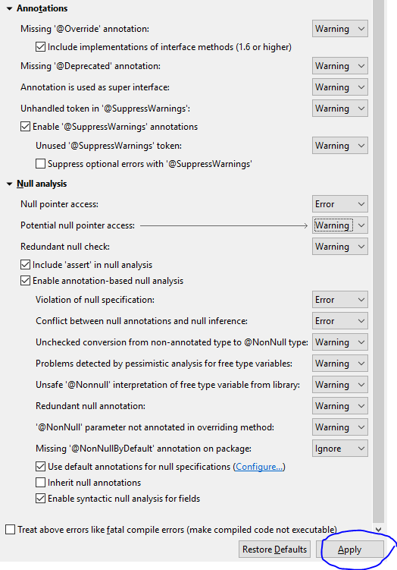

When “Applying”, it will trigger a complete rebuild of your whole workspace. When that is finished, it is good to pay attention to both of these things:

* Scroll through all the AviX projects in the Project Explorer. Ideally, none of the projects should have the red “Error” decorator, which indicates a compilation problem.